**LAB # *04***

***Introduction To Rational Rose***

### *Exercise*

* + *Create Use Case Diagram which relate to a Web site on which customers can order meals from restaurants.*

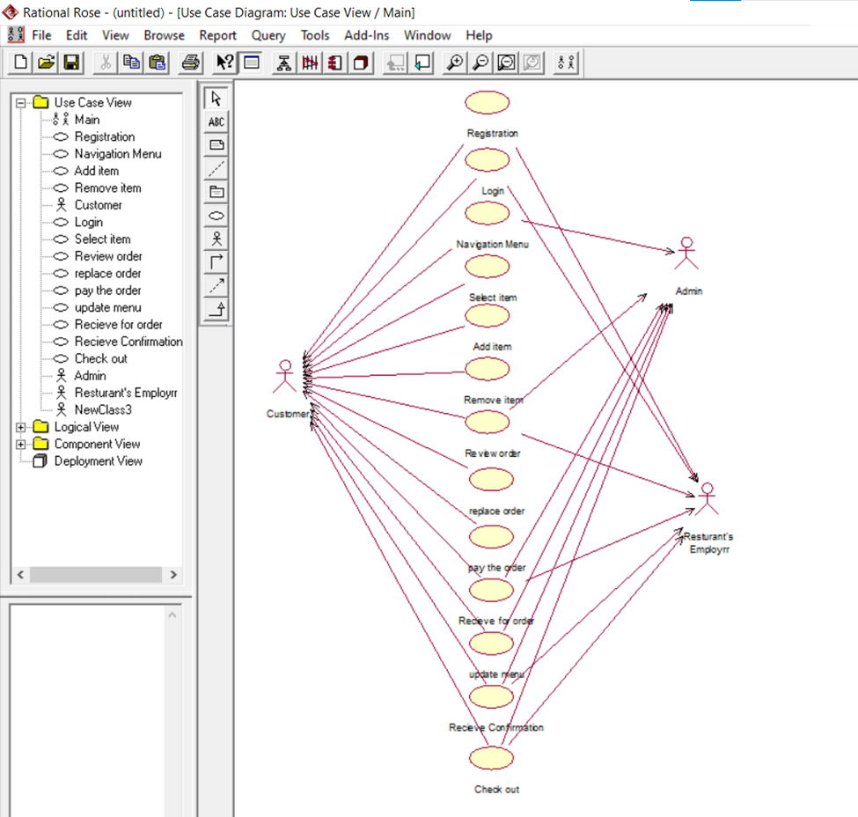

***TASK#4.2***

* + *Create Website management or administration UML use case diagram, website administrator actor could manage user groups, users, user sessions, and logs. Help Desk staff uses a subset of functions available to the Website Administrator.*

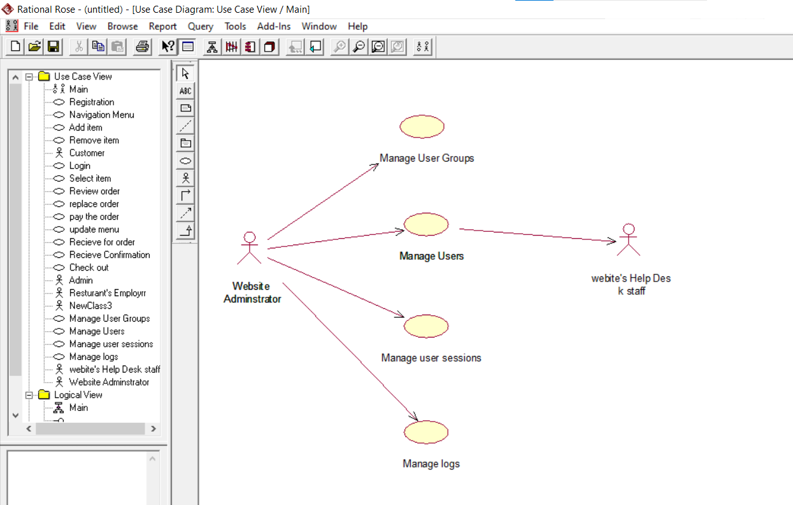

***TASK# 4.3***

* + *Create use case scenario between patient and doctor relationship.*

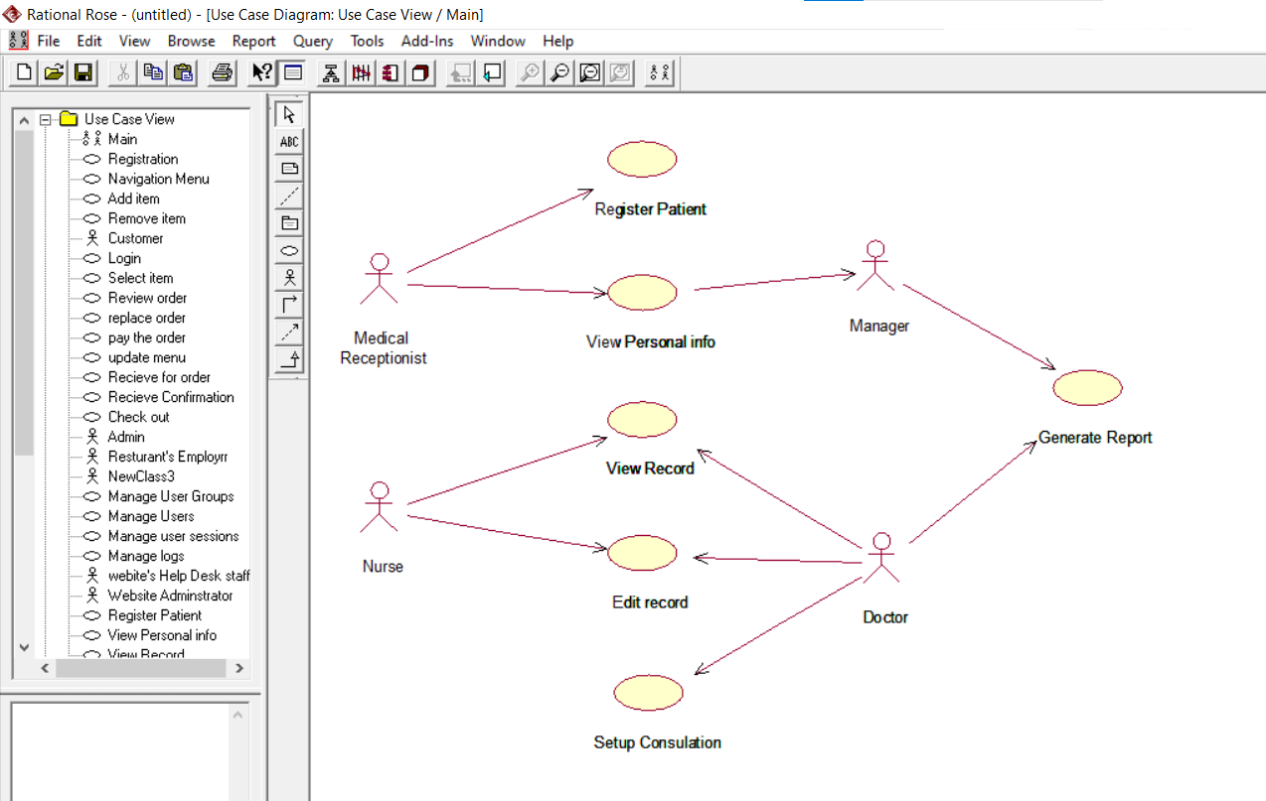

***TASK# 4.4***

* + *Create use case diagram of Login scenario. In this scenario, authorized admin and user duties*.

